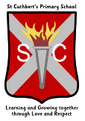

Benview Campus, 100 Bilsland Avenue, Glasgow G20 9NY Telephone: 0141 946 3476

January 2024

**St. Cuthbert’s P.S . Term 3 Newsletter**

­­

Welcome back after the Christmas break. We hope all had a good time.

This term will see our HIME report published. I’ll provide more details on this asap.

Susan Quinn, HT

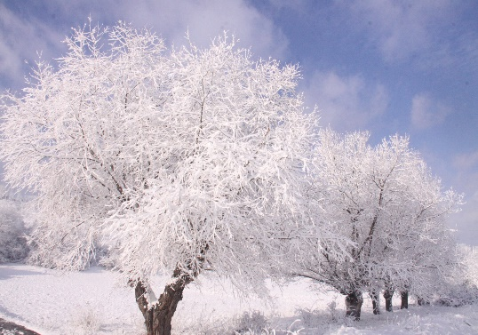

[This Photo](https://commons.wikimedia.org/wiki/File:Winter_Season.JPG) by Unknown Author is licensed under [CC BY-SA](https://creativecommons.org/licenses/by-sa/3.0/)

**Dates for the Diary**

**Burns’ Assembly –** 25th January, 9.15am, all parents welcome

**Blairvadoch Trip** – week beginning 29th January – P7

**Scottish Opera** – 9th February – all parents welcome – time to be confirmed

**First Reconciliation** – this will take place on the evening of 12th March, more details to follow.

**February Weekend** – school closed 12th and 13th February

**February Inset** – school closed to pupils on 14th February

**Close for Spring Break** – school will close at 2.30pm on Thursday 28th March

**H&S** A reminder that GCC has no smoking/vaping policies for school grounds. They also do not allow dogs within the school grounds.

**Car Park** We understand that car parking in and around the school is challenging for all. We ask that we give extra consideration when parking around the school, consider ways to a park and drive to keep everyone safe.

**Parent Council** Thanks to our Parent Council for their support in the run up to Christmas. We will look to hold a meeting early next month to organise for the future. Anyone interested please contact the office.

**Cold Weather** – as we enter the coldest period of the year we want to advise we have some spare jackets, jumpers and cardigans available if any family who may need them. Please speak to a member of staff if we can help.

**Holidays** We finish for Spring Break at 2.30pm on Thursday 28th March.