

Benview Campus, 100 Bilsland Avenue, Glasgow G20 9NY Telephone: 0141 946 3476

October 2023

**St. Cuthbert’s P.S . Term 2 Newsletter**

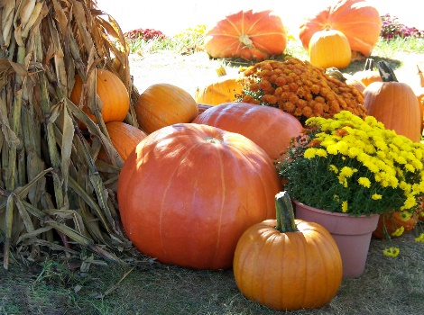­­

What a quick first term that was!

Hope you all had a lovely October break and are refreshed for the term ahead.

We are planning some lovely activities for the classes in the lead up to Christmas which we hope you will be able to get involved in.

Susan Quinn, HT

**Dates for the Diary**

**First Friday Mass** – 3/11 and 1/12 – Parents welcome to join us at 10am mass in St Teresa’s church

**Non-uniform days** – last Friday of the month

**Confirmation P7**– 16th November

**St Andrew’s Day Assembly** – 30th November at 1.30pm

**Christmas Fayre** – 7th December

**Nativity** – 14th December (9.15-10.30am and 1.30 – 3pm)

**Carol Singing, St Enoch’s** – 15th December (P6&7)

**Panto** – 19th December

**Christmas Parties** – 21st December

More info to follow on each activity nearer the time.

**H&S** A reminder that GCC has no smoking/vaping policies for school grounds. They also do not allow dogs within the school grounds.

**Car Park** We understand that car parking in and around the school is challenging for all. We ask that we give extra consideration when parking around the school, consider ways to a park and drive to keep everyone safe.

**Parent Council** Our Parent Council have planned a couple of activities for this term. The first of these is the Halloween Party on the 25th Oct followed by the Christmas Fayre on 7th December. More info to follow. If you’re interested in being on the Parent Council please let us know.

**Holidays** We finish for Christmas break on Friday 22nd December and return on Monday 8th January