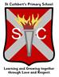
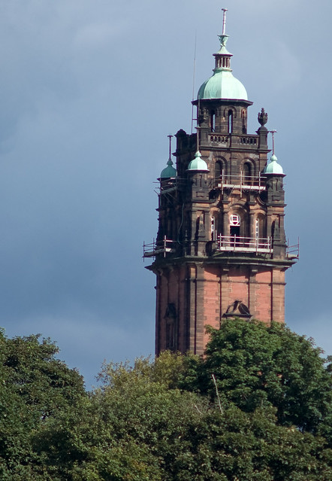
IDL

Local Study

The children will be investigating their community and the wider Glasgow area. Now, and in the future, they will be learning about the old Ruchill Hospital, the Water Tower and discussing what a listed building is.

The class will be comparing the lives of children in Glasgow 100 years ago compared to today.

They will also examine key historical figures from Glasgow’s history, for example Charles Rennie MacIntosh, how transport has changed over the last 100 years and Glasgow’s key role in shipbuilding.
Literacy 

The children will continue to be listened to reading their class reading book aloud, twice a week. They will also make weekly visits to the school library to select a personal reading book, in the pursuit of reading enjoyment.
They will take part in listening and talking lessons, learning about inspirational people using the series of books ‘Little People Big Dreams’

They will also be working on report writing skills.
Health & Wellbeing

The children will be working on Tennis and Hockey skills.

P.E. will continue to be on Monday and Tuesday afternoons and the children should continue to come to school dressed in P.E. kit on these days.

They will be learning about nutrition and health. They will also be learning about developing resilience.
St Cuthbert’s Primary School
Class Newsletter
Primary 3
Numeracy

The children will be working on the four main numeracy operations: Addition, Subtraction, Multiplication and Division.

They will also be learning about angles and directions.
Term 2 - 2023
STEM 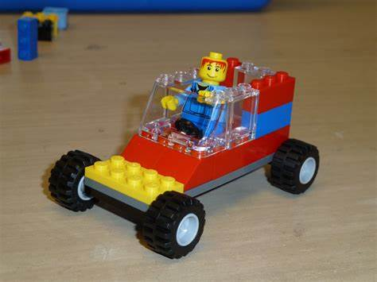

Linked to their investigation of the old Ruchill Hospital the children will be learning to design and create their own model clock tower.

Linked to their local study topic they will be building model cars using LEGO.
French 
The children’s new learning will involve numbers and counting 0-31, days of the week and months of the year. The children will learn to ask and answer about age, a third person’s name, likes and dislikes. They will also experience cultural inputs relating to Christmas in France.

Expressive Arts 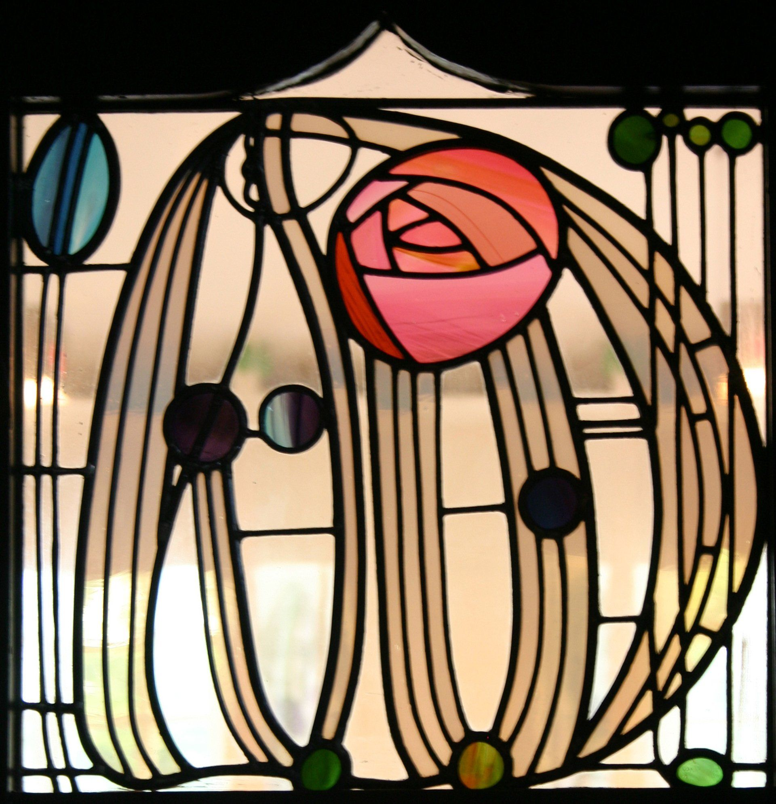

The children will be studying Charles Rennie MacIntosh as part of their investigation of Glasgow’s past. They will create Charles Rennie MacIntosh inspired designs.

