Welcome to Primary 1 at

St. Cuthbert’s Primary



*“Growing and Learning together*

*through Love and Respect”*

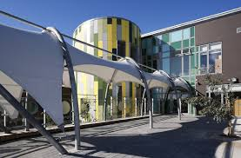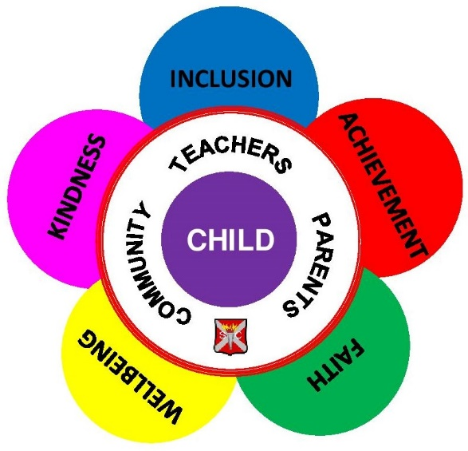

**St. Cuthbert’s Primary**

**Benview Campus**

**100 Bilsland Avenue**

**Glasgow G20 9NY**

Dear Families,

We would like to take this opportunity to welcome you to St. Cuthbert’s Primary School. We are delighted to be joining you and your child on their learning journey and we look forward to working together with you and your family over the coming years.

We hope that this booklet will provide you with all of the information you need about your child starting school and that it will help to inform you about what to expect. It aims to answer some of the questions that you may have and to put your mind at ease at this very special time.

We value our existing strong relationships with all of our families and we pride ourselves on our welcoming school ethos. We truly welcome any opportunity to support you in any way we can and we invite you to contact us at any time.

***Here at St Cuthbert’s we adopt an open-door policy. Please do not hesitate to come and see us,***

***or to contact us on the details below.***



**Telephone Number: 0141 946 3476**

**Email addresses:**

Miss Quinn (Headteacher)

[Headteacher@st-cuthberts-pri.glasgow.sch.uk](mailto:Headteacher@st-cuthberts-pri.glasgow.sch.uk)

Mrs Somerville (Principal Teacher)

Miss Differ (Principal Teacher)

Mrs Stewart ( Clerical)

[ZStewart@st-cuthberts-pri.glasgow.sch.uk](mailto:ZStewart@st-cuthberts-pri.glasgow.sch.uk)

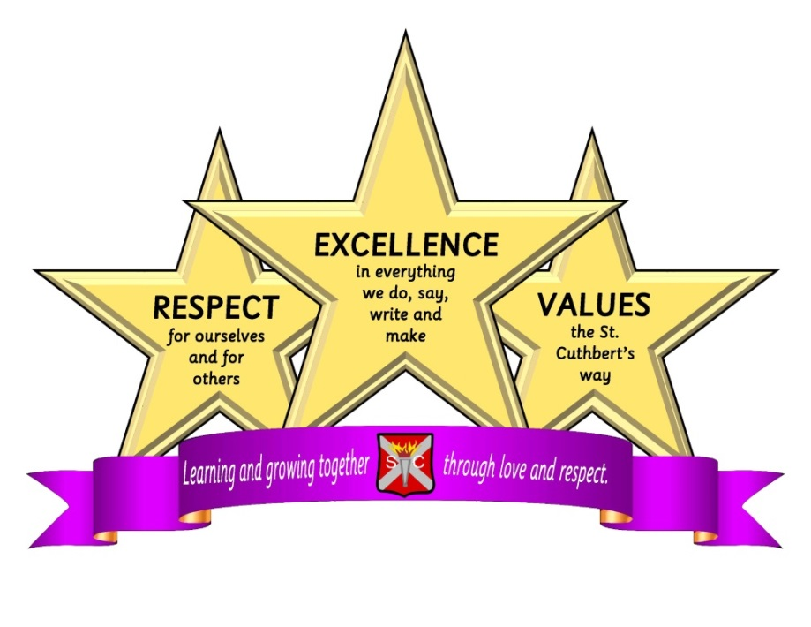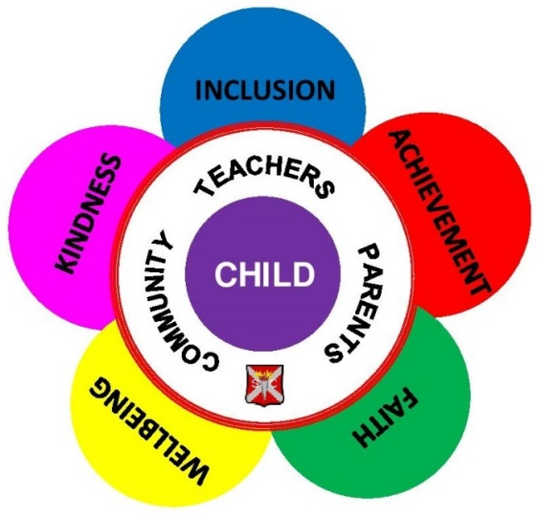

**School Vision and Values**

*Here at St. Cuthbert’s, our school vision is –*

**‘Learning and Growing together**

**through Love and Respect’**

*Our values are -*

**Inclusion, Achievement, Faith,**

**Wellbeing and Kindness**

*And we have three school rules -*

**Respect, Excellence and Values**



**Our school day**

**School starts at 9am**

**Playtime is at 10.30 -10.45**

**Lunchtime is at 12.15 -1.00**

**School ends at 3pm**

*We ask you to ensure that children are in their line for the*

*bell ringing in the morning and ready to start the school day with*

*their class. This helps children to have a settled start to the day*

*and allows them to socialise before the day begins.*

**Emergency Contact**

It is important that the school have your up to date Emergency Contact details. If your phone number or details change, please let us know straight away.

**Absences**

If your child is sick, please let the office know before 9.15am. This ensures that we have accounted for all children and can put measures in place if a child is missing from school.

**Medicine**

If your child requires medicine, please inform the office staff in the first instance. School staff are not allowed to give children medicine unless a permission form has been signed by the parent/carer. Should your child require medicine to be kept in school on a more regular basis, for example, an inhaler, please ensure that they are replaced regularly.

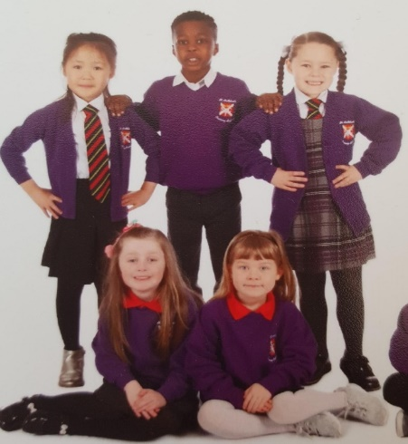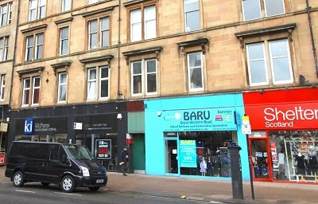

**Uniform stocked at:**

**BARU**

216 Great Western Road

Glasgow

G4 9EJ

0141 332 1266

http://www.kitmykid.co.uk/

**School Uniform**

**\*\*PLEASE PUT YOUR CHILD’S NAME ON ALL ITEMS\*\***

**Boys Girls**

School tie School tie

Red pullover Red pullover/cardigan

White shirt White shirt

Grey or black trousers Grey or black skirt/pinafore

Dark shoes Dark shoes

PE Kit (Boys/Girls): *T-shirt, shorts and slip on gym shoes*

**You will find examples of our uniform on our website -**

<http://www.st-cuthberts-pri.glasgow.sch.uk/>

Or on our twitter page - @stcuthbertsglas

**You will find most uniform items in shops such as –**

**You can buy ties and embroidered pullovers/cardigans at –**

**BARU**

216 Great Western Rd

Glasgow G4 9EJ

0141 332 1266

<http://www.kitmykid.co.uk/>

**Information on CLOTHING GRANTS can be found at –**

[www.glasgow.gov.uk/article/17885/Clothing-Grants-and-Free-School-Meals](http://www.glasgow.gov.uk/article/17885/Clothing-Grants-and-Free-School-Meals)

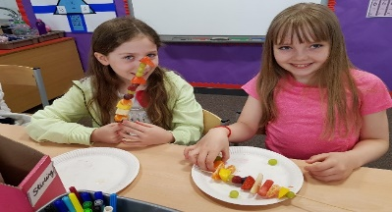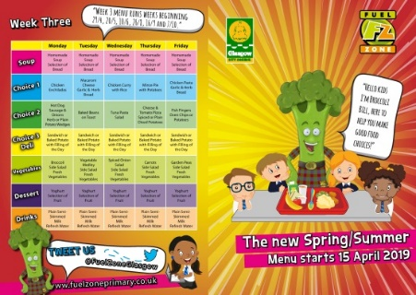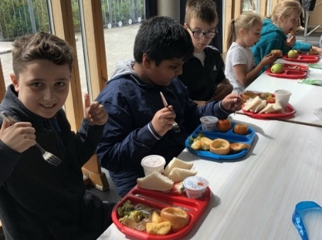

Making fruit kebabs as a healthy morning snack

**School Lunches**

In Scotland school lunches are free for all children from P1-5

**Further information on FREE SCHOOL MEALS**

**for children in can be found at –**

[www.glasgow.gov.uk/article/17885/Clothing-Grants-and-Free-School-Meals](http://www.glasgow.gov.uk/article/17885/Clothing-Grants-and-Free-School-Meals)

The menus change each term and can be found on the Glasgow Fuel Zone Website at <http://www.fuelzoneprimary.co.uk/>

It runs on a three-weekly menu and offers standard, vegetarian and Halal options.

**Healthy Choices**

We are a Healthy Snack School and all of our children stop We encourage healthy choices, such as fruit or vegetable sticks.

*We ask that you do not send children in with chocolate, crisps or sweeties. Keep these treats for when they are with you! Children are also encouraged to bring water to school. We have two water coolers in the corridors, where they are able to fill a bottle from home.*

By having snack in the classroom, it helps us to reduce litter in the playground, but also encourages the children to use their 15 minute break to play and run around.

**Playtimes**

Children enjoy playtime between 10.30-10.45am and after lunch. During these times they benefit from opportunities to play with children from other classes, and they are supported to develop and enhance their social skills and confidence.

Our support assistants provide a strong presence in the playground, where they actively encourage the formation of strong relationships, reinforcing our values of Inclusion and Kindness.

We have a variety on playground resources, which help to challenge our children’s problem-solving and resilience skills and encourage collaboration and teamwork!

As children learn to take more risks during play, they can have bumps and falls. A ‘bump note’ will be sent home if your child has a bump to the head.

**Catholic Ethos and Values**

As a Roman Catholic Primary School, we hold the Gospel Values core to our ethos.

**Prayers**

Children join in class prayers in the morning, before lunch, after lunch and before home time. Prayers are a good way of encouraging children to calm their minds and bodies.

**Mass**

Our links with the local parish church

means that we have regular masses

throughout the year to celebrate feast

days. These masses are held at

St. Teresa’s Church, where we also celebrate First Friday Mass.

**Buddies**

Children in Primary 1 will be assigned a Primary 6 Buddy. This system has been successful in previous years in helping to enhance the transition between nursery and school.

New children are given opportunities to get to know their Buddy in Term 3 of Nursery, which allows them to get to know them before starting school. This enables them to build positive relationships throughout their transition and it provides them with a friendly face during playtimes whilst they develop friendships in the early days.

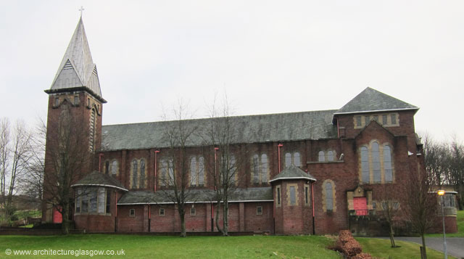

**Learning in Primary 1**

**Playful Pedagogy**

Glasgow Council strongly advocates the benefits of the Playful Pedagogy approach, which we deliver to the very highest standards here at St. Cuthbert’s Primary. Your child’s learning will be steeped in rich, meaningful learning experiences through the context of Play. This is supported by a substantial body of research that links play to a range of learning and developmental outcomes, including: cognitive development and higher order thinking skills, language and literacy, numeracy and mathematical understanding, physical development, social competence and self-regulation of emotion and behaviour. This is an approach that we strongly endorse, and we look forward to involving you in this process and providing further information at future events.

**Family Learning**

We understand that the best way for children to learn is to work closely with families. We are very committed to working in partnership with you and we will be offering many future events and opportunities for you to become involved in your child’s learning.



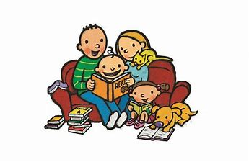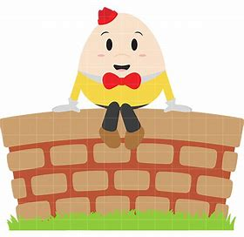

**What can I do to help my child in Primary 1?**

A very important way to help your child with their early learning is to read or tell them lots of stories and nursery rhymes. Nursery Rhymes are extremely important to your child’s development. Sing and chat about Nursery Rhymes with your child - you will find lots on Youtube. This helps them to hear different sounds, patterns and rhymes which will help with reading in P1.

Have conversations with your child about what they think, what they understand and how they feel about things that affect them.

Encourage them to dress themselves and practise opening and fastening buttons.

Encourage them to run, hop, skip, jump, climb etc. Making big body movements like these will help to develop their gross motor skills which will support their development of other skills.

Encourage them to play with pencils and crayons. This will develop their fine motor skills and help them to develop their pencil grip.

Play lots of games which help them to recognise colours and shapes. For example, ‘Can you pass me a red crayon, please?’ or ‘Point to the blue triangle in the picture’.

Practise saying numbers from 0 upwards. It is important to practise saying them backwards too. It is important that children can make the link between the number and the value. Playing games that involve rolling a dice is good for this.

Ask them to tell you the number that comes ‘after’ and ‘before’ a number, or the number that comes ‘in-between’.

Play games such as Eye Spy, remembering to say the letter as it sounds rather than using its name. For example, ‘I spy with my little eye something beginning with the sound...b” (instead of ‘bee’). It is important to teach the letter as it sounds before using the letter name.