
IDL –

This term our topic will be ‘Wild Animals’. We will be exploring the different habitats of wild animals all around the world, and how they are adapted to their natural environment. We will look at their different features, diet and food chains. We will explore this through art as well, practising our sketching and use of colour through creating different landscapes and animals, drawing and labelling pictures and diagrams.

Literacy
Primary 4 will be continuing to develop their reading fluency through reading aloud in class. Our focus this term will be non-fiction. They will be developing their selecting and sorting skills through reading information from different non-fiction texts.
We will be focusing on persuasive writing this term.
Health & Wellbeing

Monday and Wednesday will be Primary 4’s P.E. days. Please ensure your child has full P.E. kit on this day.

This term we will be focussing on the world of work and exploring different jobs in the community, and what skills and abilities are needed for them.
We will also be looking at the different food groups and how they contribute to a healthy diet. We will explore daily hygiene routines and discuss why they are important.

St Cuthbert’s Primary School
Class Newsletter
Primary 4 – Term 4 2024
Numeracy
Primary 4 will be learning about measure this term. They will develop their skills of estimating and measuring length, measuring weight, as well as converting units of measure. They will also learn to calculate perimeter and area of different shapes.
Technology
This term we will be learning how to use different features of chromebooks. We will look at creating word documents, using search engines, using copy and paste shortcuts, and we will also look at internet safety.

Other Information

Thank you for your continued support, Mrs Williams and Mrs Louden.

French 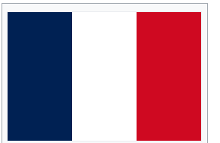
P4 will carry on using questions and class routine language learned so far in our French lessons. Primary 4’s will continue to discuss where they live and homes. This will include learning to describe their dream home, including their ideal holiday homes.

